November 22, 2022
Ref: IIH/MD/2022/11/005

His Excellency,
The Executive Governor of Kwara State,
Government House,
Ahmadu Bello Way,
GRA, Ilorin, Kwara State

Your Excellency Sir,

REQUEST FOR APPROVAL TO RELEASE FUNDS FOR PAYMENT OF KWARA STATE GOVERNMENT GOOGLE WORKSPACE EMAIL & COLLABORATION TOOLS FOR
JAN-JUN 2023

I write to request the funds for 6 month renewal of the GSuite (Google Workspace Collaboration Tools) email addresses for Kwara State Principal officers for the period of January 2023 – June 2023. Due to the fact that these costs are all billed in dollars and the recent increase of the dollar against the naira, I humbly ask this be treated quickly before any further inflation. The payment for the period of July-Dec 2022 has been made.

SN | DESCRIPTION | QTY | RATE | DURATION | PRICE ($) | PRICE (N)*
 | Kwara State .gov Email
1 | Google Workspace Business Edition | 80 users | $12/user | 6 months  Jul-Dec 2022 | 5760 | 4,320,000
2 | Service Charge 20%** |  |  |  |  | 864,000
 | Sub-Total |  |  |  |  | 5,184,000
 | VAT 7.5% |  |  |  |  | 388,800
 | GRAND TOTAL |  |  |  |  | 5,572,800

* This conversion was done at the current market rate of USD1 = NGN750 as at Nov 22, 2022
** Service charge is to cover statutory government deductions as the costs are paid to Google, a third party vendor

I anticipate prompt payment so as to avoid disruption of service and continued smooth communication and collaboration within the State Government.

Yours sincerely,
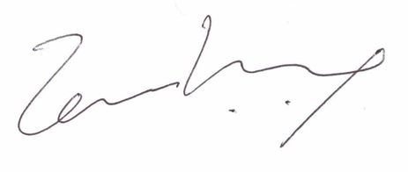
Temi Kolawole
ag. Managing Director

